Robot monsters need three different parts. They need a head, a body and legs.

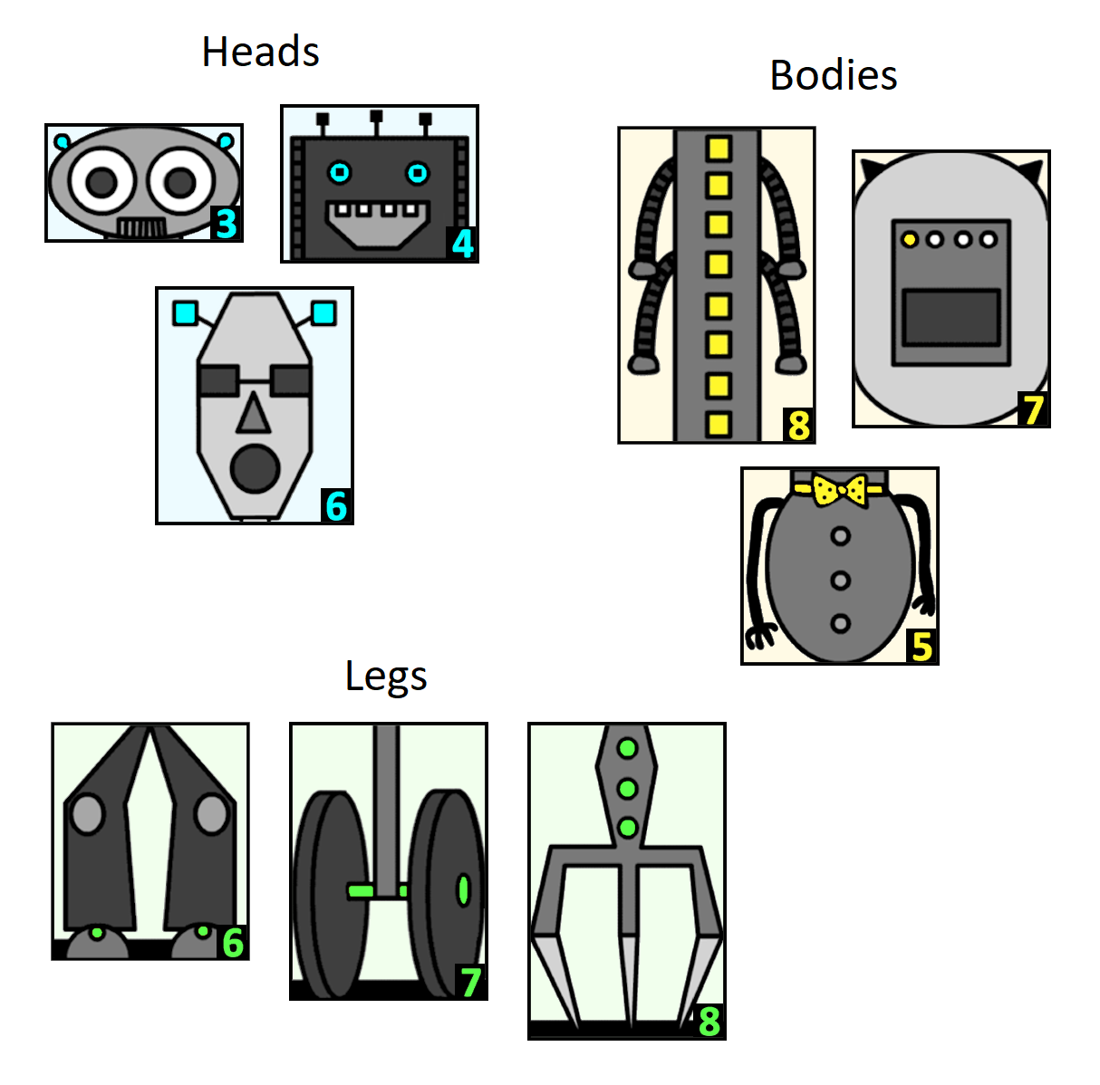

Using some of the robot parts on the next page, make a robot monster!

The numbers show how tall the parts are in centimetres. How tall is your robot monster?

How tall is the tallest robot monster you can make?

What about the shortest robot monster?

What other heights could your robot monster be?

Can you find all the possible heights of a robot monster? How do you know you have found them all?

Robot parts to cut out:
